Introduction: Understanding the Global Burden of Tuberculosis
Tuberculosis (TB) is one of the world’s oldest infectious diseases, but it is still a major health problem today. Millions of people continue to fall sick every year, and many die.
This dashboard project looks at how TB has changed over time and what factors have influenced it during the period from 1990 to 2013.
To make the story easy to follow, the dashboards are divided into four parts:

1. Global Burden Overview
It presents the total number of reported TB cases and deaths across all countries, the nations with the highest incidence, and how the burden is split by region.
It helps us understand where TB is most common and how big the challenge is worldwide.

2. Evolution of TB Indicators Across Regions
It shows how TB indicators (like mortality, incidence and prevalence rates) have changed in each region.
By comparing the lines across regions, we see that some areas improved faster while others struggled, especially Africa in the early 2000s.

3. HIV Influence on TB
The third dashboard explains why TB trends behaved this way.
this dashboard tells how HIV made TB worse, and how global action helped reverse the damage.

4. Case Detection Rate
The final dashboard looks at how well each region finds and reports TB cases.
Even if a country has many TB cases, detection determines whether people get treatment.
These charts show steady progress over time — especially in South-East Asia and Africa — and highlight regions that already had strong detection systems, like the Americas and Europe.
It tells us how the world is improving at tracking and controlling TB

Actions:

you can see the corresponding data in other plots if you hover a point.

You can see each result in different period using the starting year and end year

you can select among (incidence, prevalence and mortality) in the second dashboard as the parameter.

parameters:

Starting year: (1990 – 2013)

End year: (1990 - 2013)

TB metrics: (incidence, prevalence, mortality)

Filters:

Year range: (1990 – 20113)

Dashboards:

Global Burden Overview:

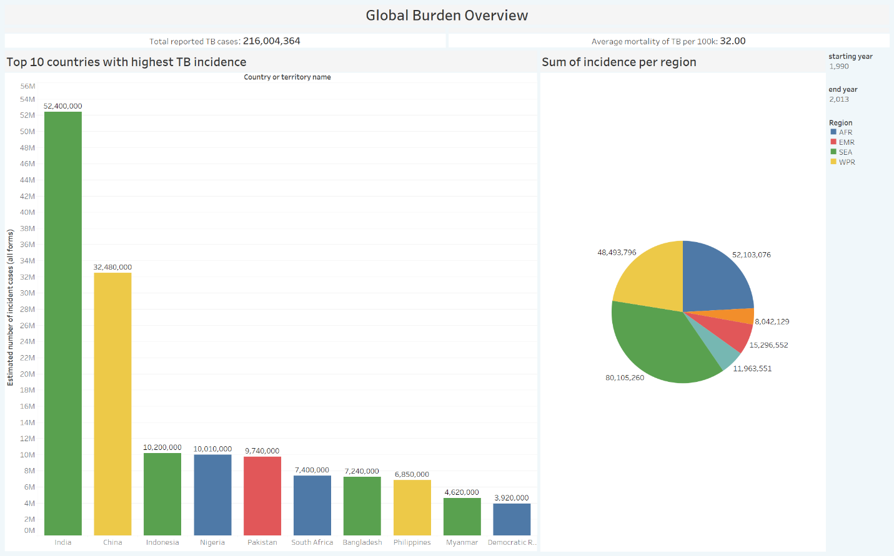

Total reported TB cases: 216,004,361 / Average mortality of TB per 100K: 32
Between 1990-2013 there were over 216 million incidence of TB and the mortality rate of 32 person per 100k clearly show that it was a significant global health challenge. But it TB wasn’t distributed evenly over the world and different regions has different share in this challenge. For instance India (52M) and China (32M) had the most incident among different countries and no surprise that SEA had the most share in TB among regions. While this dashboard gives us a clear view of the TB effect, we’re going to see it's statistics over different years in next dashboard.

Evolution of TB Indicators Across Regions:

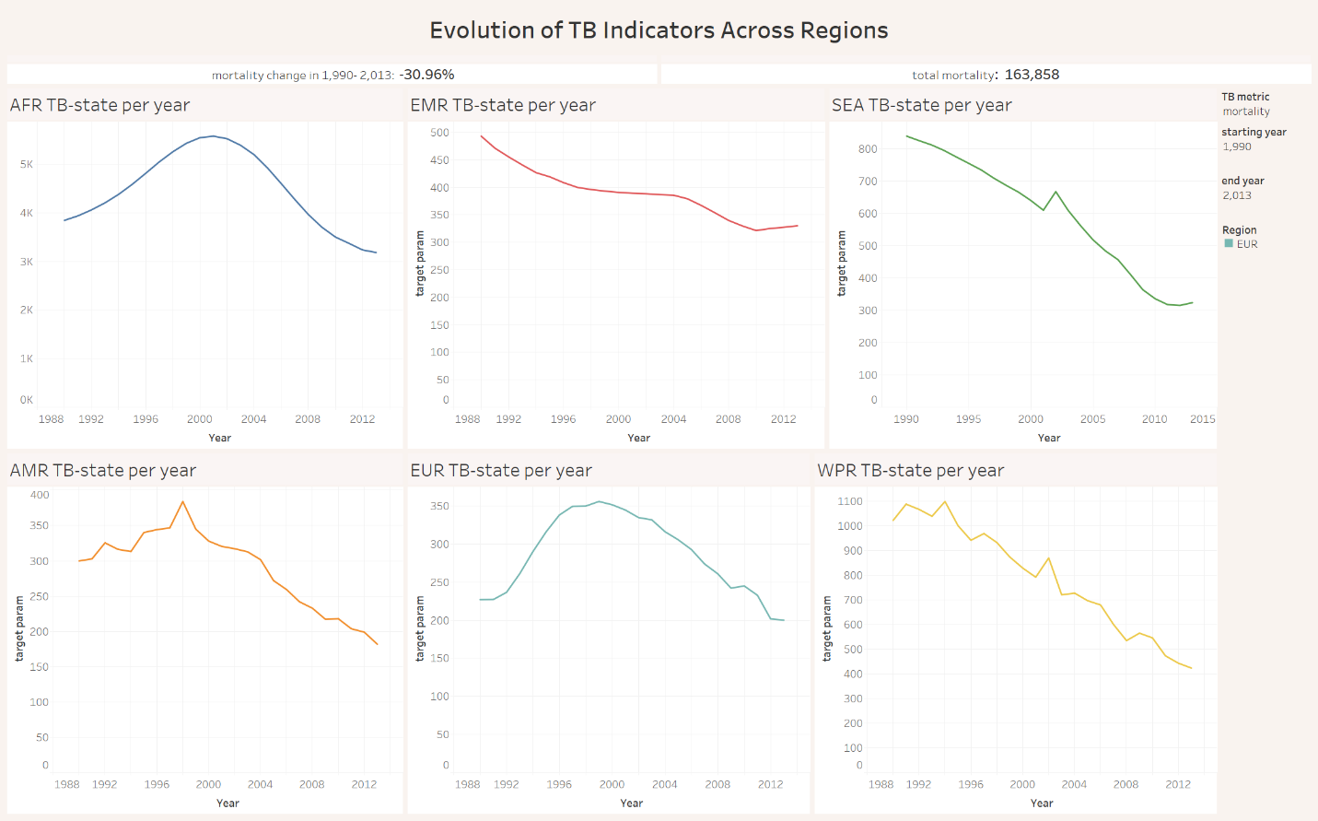
Mortality change: -30.96% / total mortality: 163,858
While the global burden is heavy, the story of the last two decades is one of incredible progress. Between 1990 and 2013, we have seen a 30.96% reduction in TB mortality. This dashboard breaks down that success by region, showing that while the downward trend is nearly universal, the timing and the struggle were very different. The most striking trend is in the African Region (AFR). Unlike other regions that started declining early, Africa saw a massive surge in TB deaths throughout the 90s, peaking around 2002-2003.
The Western Pacific (WPR) and South-East Asia (SEA) regions are the ‘steady performers. Despite having some of the highest absolute numbers of cases, they have maintained a consistent downward trajectory for over 20 years, contributing most significantly to the global mortality drop. you can see the same trend if you toggle the TB metric for (incidence – prevalence) too.
This dashboard proves that the ‘Global Burden’ isn’t static. It is a moving target. By looking at these trends, we can see that interventions work but the timing of their success was different.

HIV Influence on TB:

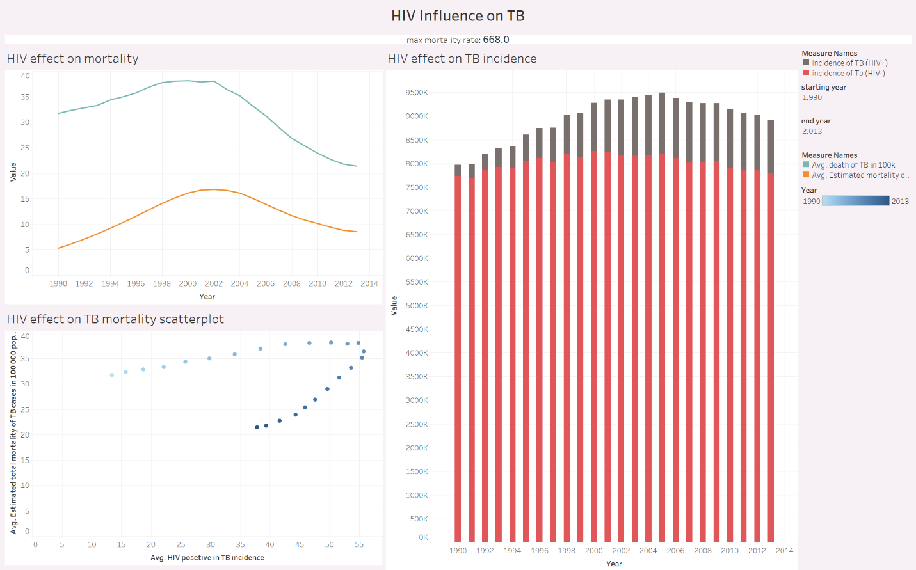
Max mortality rate: 668
TB has existed for centuries, but the AIDS epidemic of the 1990s changed its speed. This dashboard reveals how the emergence of HIV reshaped global TB patterns over two decades.
In the early 1990s, TB mortality rates were already high, but once HIV spread widely, deaths among HIV positive individuals increased (orange curve). You can see with the reducement of HIV death, TB mortality reduced too.
The bar chart separates total TB incidence into two populations: those living with HIV (grey) and those without (red).
During the late 1990s and early 2000s, total cases ballooned — not because TB itself changed, but because the HIV epidemic surged, causing latent TB infections to convert into active disease.
Even a small grey segment at the top represents millions of people whose immune systems were too weak to contain TB bacteria.
You can see clearly in scatter plot the correlation of HIV incidence and mortality of TB in different years.

Case Detection Rate:

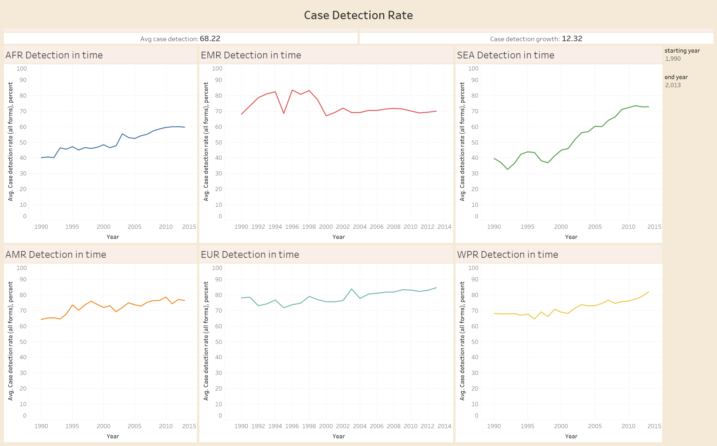
Avg case detection: 68.22 / case detection growth: 12.32
Here we can see different case detection rate in regions. That shows the health system wasn’t equal in the world and we can see Europa maintained a good shape from the starting point with near 80% case detection while somewhere like Africa was struggling from the poor 40% case detection to reach 60%. That clearly shows why the mortality per population was so high in Africa.
The Success of South-East Asia: One of the most impressive trends is in South-East Asia (SEA). This region started even lower than Africa (around 35%) but achieved a strong, consistent increase to over 70%. This suggests a massive and successful effort in public health mobilization.

Final Insight
The analysis of the global Tuberculosis (TB) data from 1990 to 2013 reveals a narrative of significant progress tempered by massive regional burdens. While case detection and mortality rates are moving in the right direction, the concentration of the disease in specific geographies and its link to HIV remain the primary obstacles to eradication.

1. High Geographic Concentration of the TB Burden
The global burden is not evenly distributed. A staggering 216 million cases have been reported, with the South-East Asia (SEA) and African (AFR) regions are the most effected regions in the epidemic period. Specifically, India (52.4M) and China (32.4M) stand out as the highest-incidence countries. This show clearly the vast distribution of the TB across the world.

2. Success in Case Detection and Diagnosis
There has been a positive trend in the Case Detection Rate (CDR), which now averages 68.22% globally.
- The data shows a 12.32% growth in detection efficiency over the study period.
- Regions like Western Pacific (WPR) and South-East Asia (SEA) have shown the most dramatic and steady improvements since 1990.
- Higher detection rates are critical for treatment.

3. Reversing the Mortality Trend
The “Evolution of TB Indicators” dashboard shows a large growth and then slowly reducing in mortality across most regions.
- The “Peak and Decline” Pattern: Most regions (notably Africa and Europe) saw mortality peak in the late 1990s or early 2000s followed by a steady decline.
- Success Stories: The Western Pacific (WPR) and Eastern Mediterranean (EMR) regions have achieved the most consistent reductions in mortality, demonstrating the effectiveness of sustained public health interventions.

4. The HIV-TB Co-Epidemic: A Critical Risk Factor
The data confirms a strong correlation between HIV prevalence and TB mortality.
- The scatterplot analysis shows that as the percentage of HIV-positive TB patients increases, the mortality rate rises sharply.
- The peak in TB mortality observed around 2002 across several dashboards aligns closely with the peak of the global HIV epidemic, proving that TB control cannot be achieved in isolation from HIV management.

Final Summary
The global fight against TB is at a turning point. We have successfully increased the average case detection by 12% and reversed the mortality trends that peaked a decade ago. However, with over 216 million reported cases, the scale remains massive. And we understood the high correlation between HIV and TB which requires more investigation.

